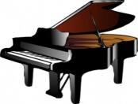 My initial thoughts about ‘The Piano’
I believe that this film is about ...

The central/main character is ...

The film tells us about/tries to convey ...

The part that had the greatest impact on me was ....

